Day 20 25th july 2025

OOAD
Object Oriented paradigm, Design Patterns, Design Workflow, Refactoring

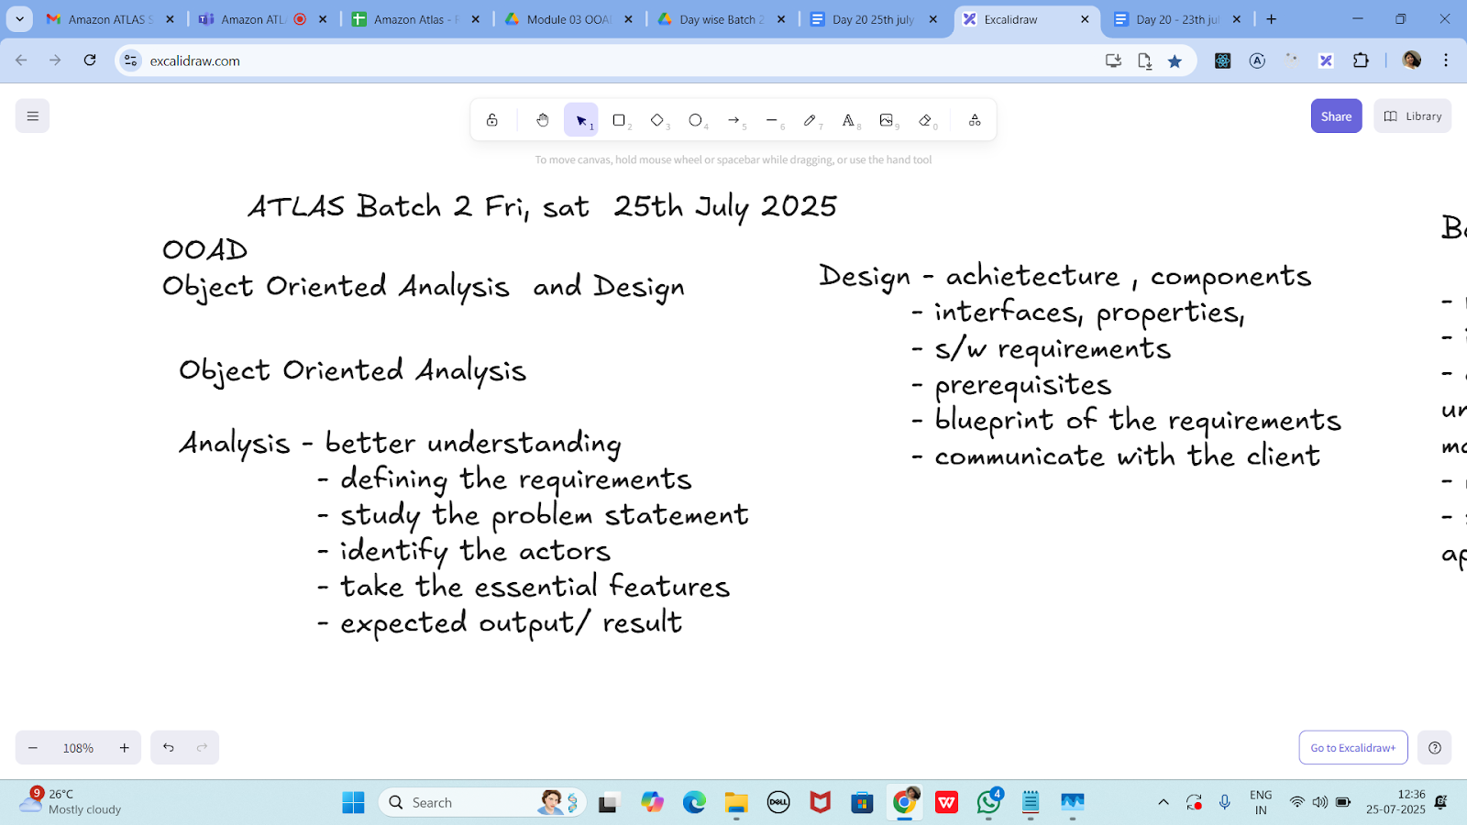

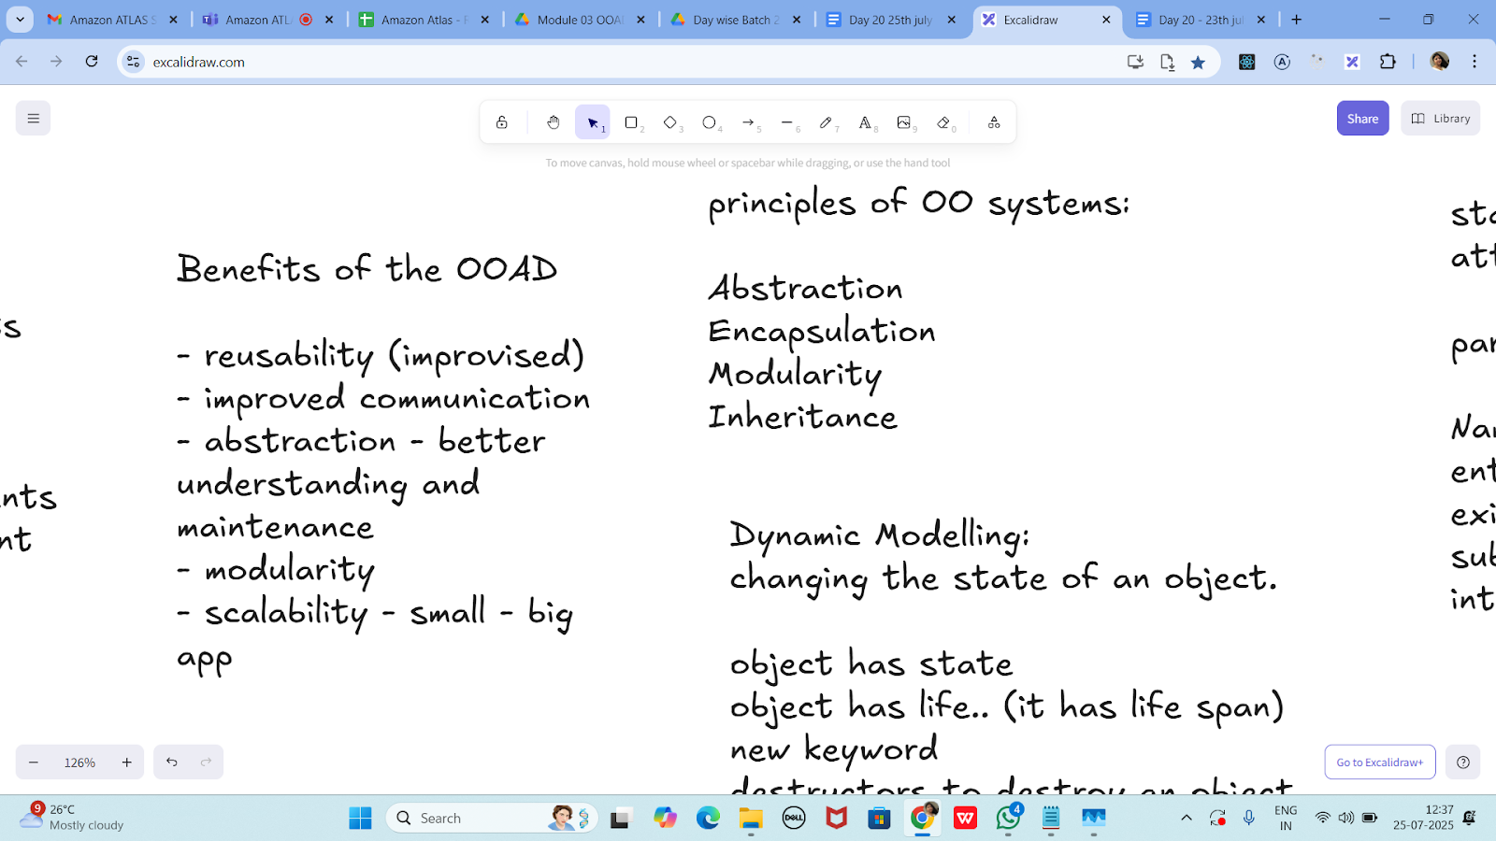

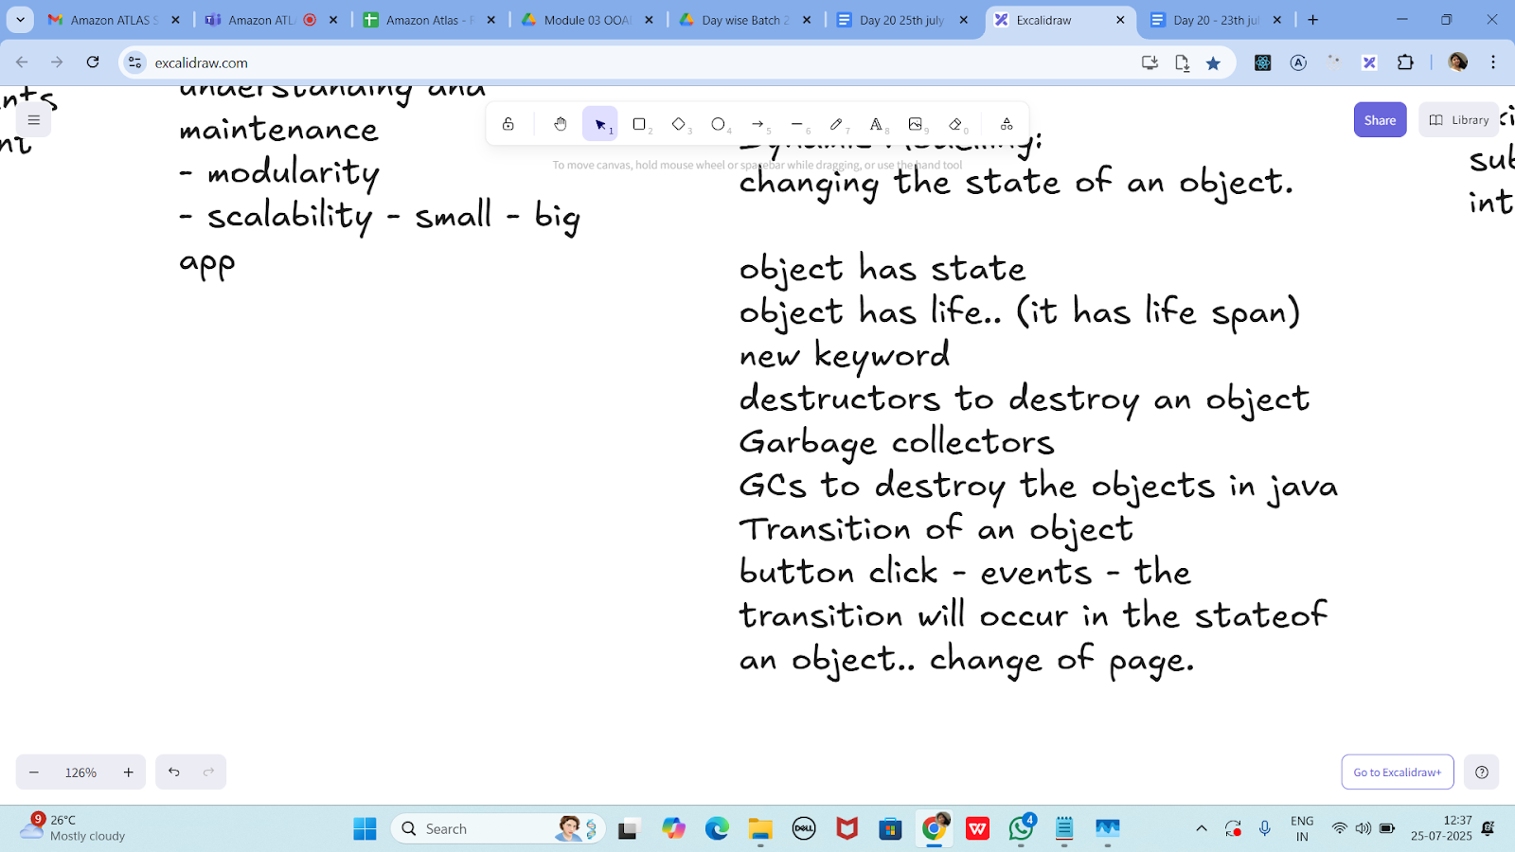

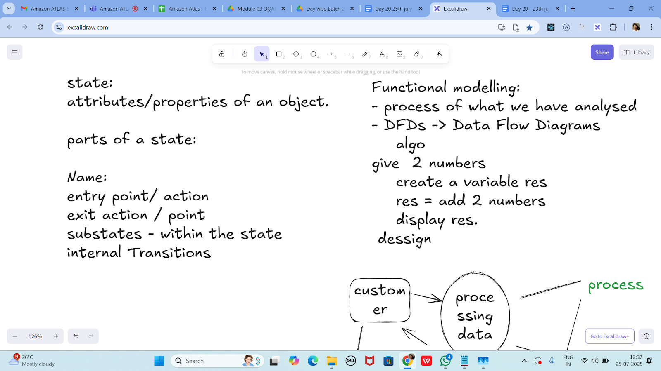

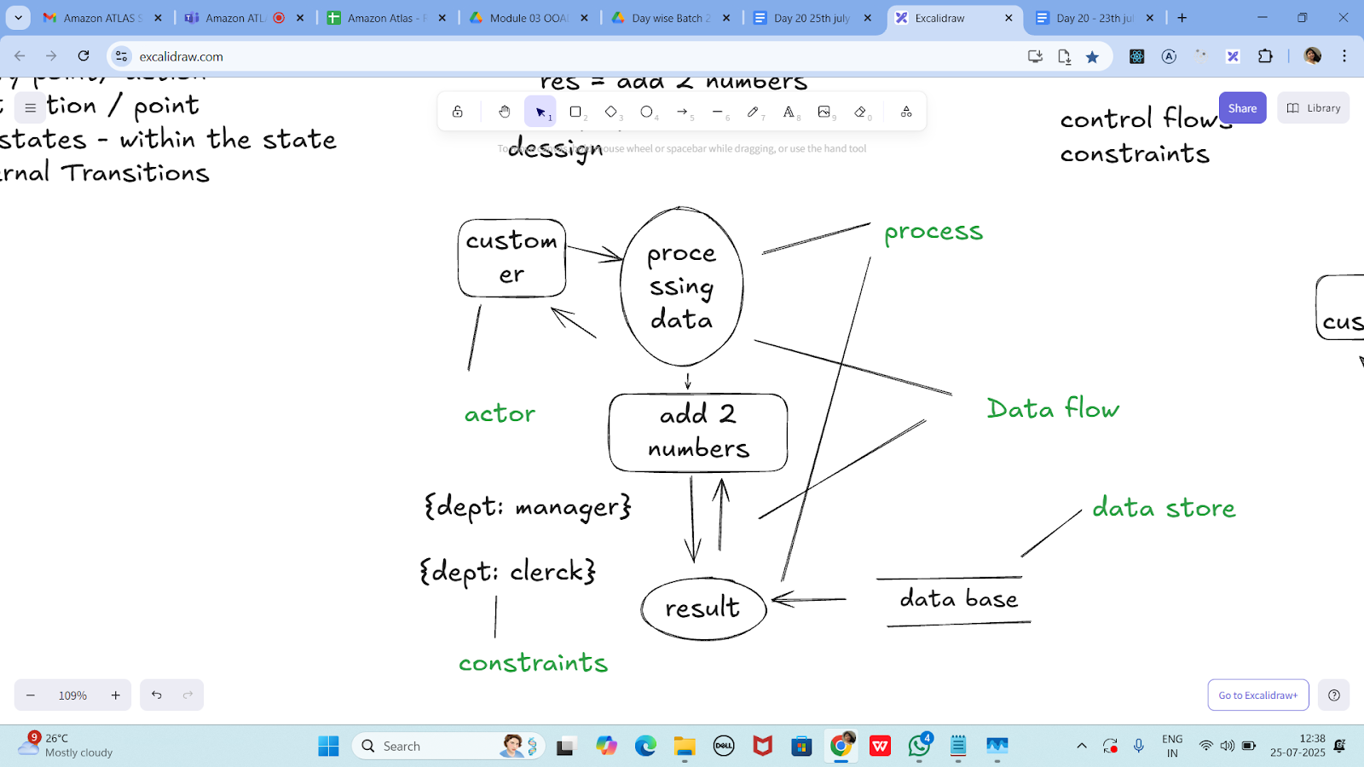

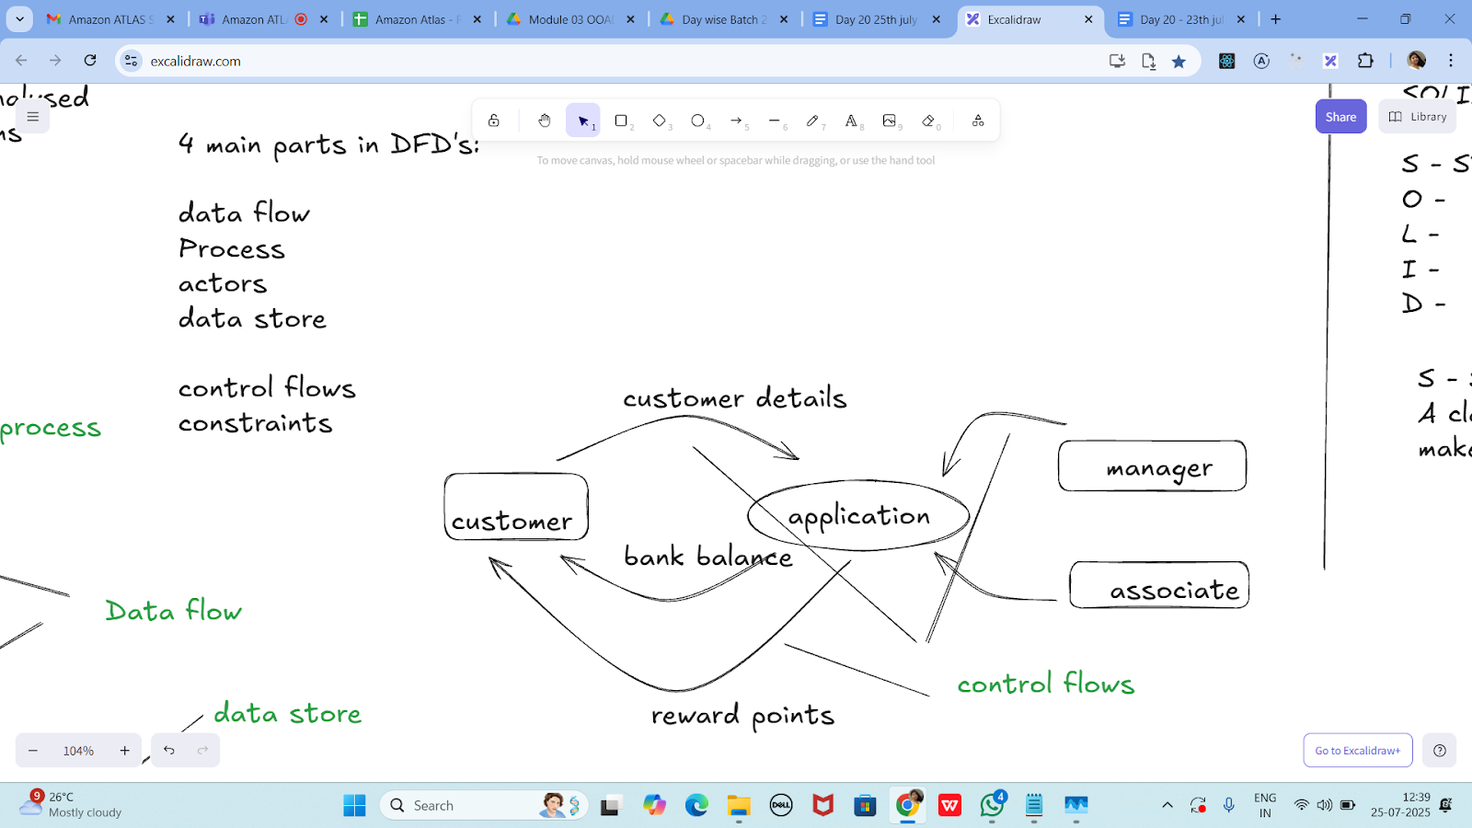

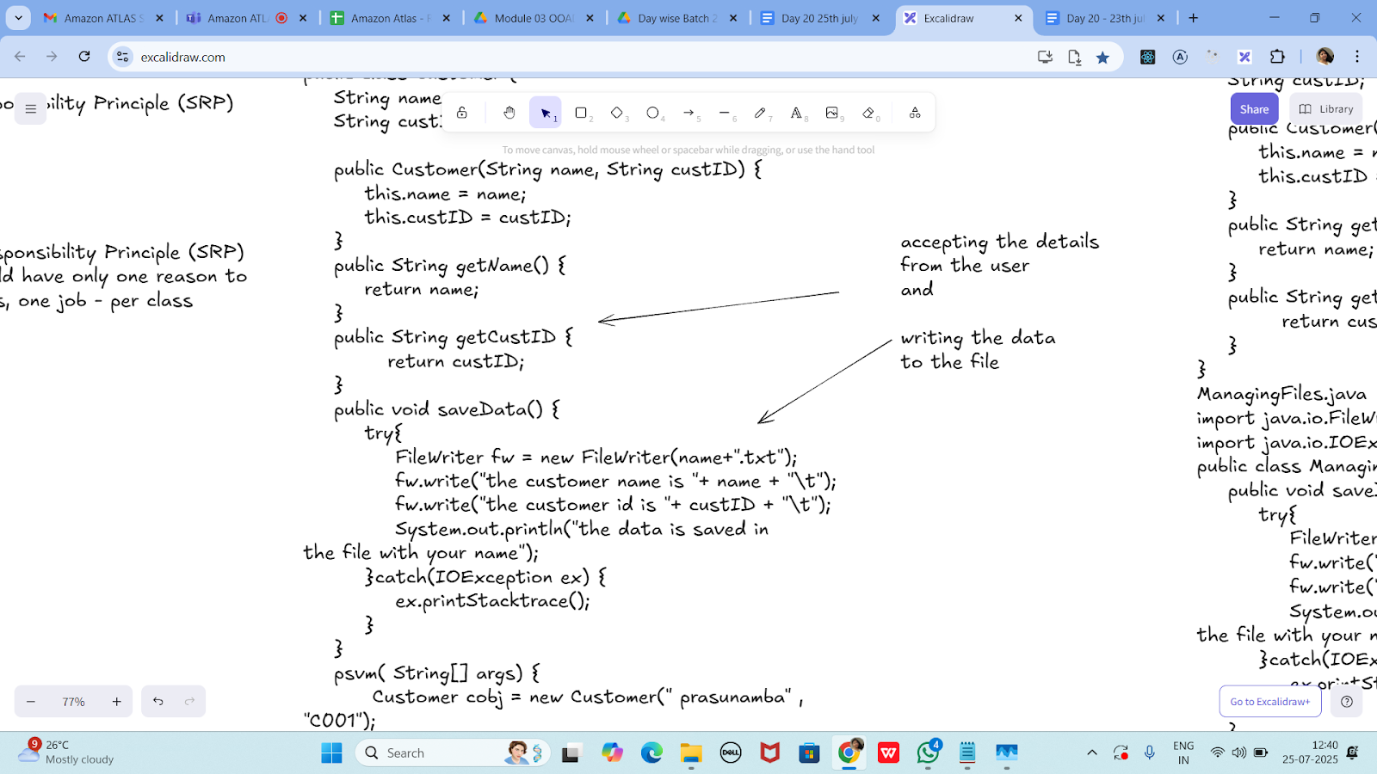

Without SRP:
SRP violation code

public class Customer {
String name;
String custID;

public Customer(String name, String custID) {
this.name = name;
this.custID = custID;
}
public String getName() {
return name;
}
public String getCustID {
return custID;
}
public void saveData() {
try{
FileWriter fw = new FileWriter(name+".txt");
fw.write("the customer name is "+ name + "\t");
fw.write("the customer id is "+ custID + "\t");
System.out.println("the data is saved in
the file with your name");
}catch(IOException ex) {
ex.printStacktrace();
}
}
psvm( String[] args) {
Customer cobj = new Customer(" prasunamba" , "C001");
cobj.saveData();
}
}

import java.io.FileWriter;
import java.io.IOException;

public class Customer {
String name;
String custID;

public Customer(String name, String custID) {
this.name = name;
this.custID = custID;
}

public String getName() {
return name;
}

public String getCustID() {
return custID;
}

// ❌ This method violates SRP - Customer class should not handle file saving logic
public void saveData() {
try {
FileWriter fw = new FileWriter(name + ".txt");
fw.write("Customer Name: " + name + "\n");
fw.write("Customer ID: " + custID + "\n");
fw.close();
System.out.println("Data saved in file named after the customer.");
} catch (IOException ex) {
ex.printStackTrace();
}
}

public static void main(String[] args) {
Customer cobj = new Customer("Pratheesh", "C001");
cobj.saveData();
}
}

SRP Implementation:

Customer.java
public class Customer {
String name;
String custID;

public Customer(String name, String custID) {
this.name = name;
this.custID = custID;
}
public String getName() {
return name;
}
public String getCustID {
return custID;
}
}
ManagingFiles.java
import java.io.FileWriter;
import java.io.IOException;
public class ManagingFiles{
public void saveData() {
try{
FileWriter fw = new FileWriter(name+".txt");
fw.write("the customer name is "+ name + "\t");
fw.write("the customer id is "+ custID + "\t");
System.out.println("the data is saved in
the file with your name");
}catch(IOException ex) {
ex.printStacktrace();
}
}
}
SRP_Imple.java
public class SRP_Imple {
psvm( String[] args) {
Customer cobj = new Customer(" prasunamba" , "C001");
ManagingFiles mobj = new ManagingFiles();
mobj.saveData();
}
}

import java.io.FileWriter;
import java.io.IOException;

// Class that holds Customer2 data — single responsibility
class Customer2 {
private String name;
private String custID;

public Customer2(String name, String custID) {
this.name = name;
this.custID = custID;
}

public String getName() {
return name;
}

public String getCustID() {
return custID;
}
}

// Class that handles file operations — single responsibility
class ManagingFiles {
public void saveData(Customer2 Customer2) {
try {
FileWriter fw = new FileWriter(Customer2.getName() + ".txt");
fw.write("The Customer2 name is: " + Customer2.getName() + "\n");
fw.write("The Customer2 ID is: " + Customer2.getCustID() + "\n");
fw.close();
System.out.println("Data saved to file with the Customer2's name.");
} catch (IOException ex) {
ex.printStackTrace();
}
}
}

// Public class for execution — only one public class allowed
public class SRP_Imple {
public static void main(String[] args) {
Customer2 cobj = new Customer2("Prasunamba", "C001");
ManagingFiles mobj = new ManagingFiles();
mobj.saveData(cobj);
}
}

—---------------------------------------------------------------------as of 12.41………………………………

OCP -

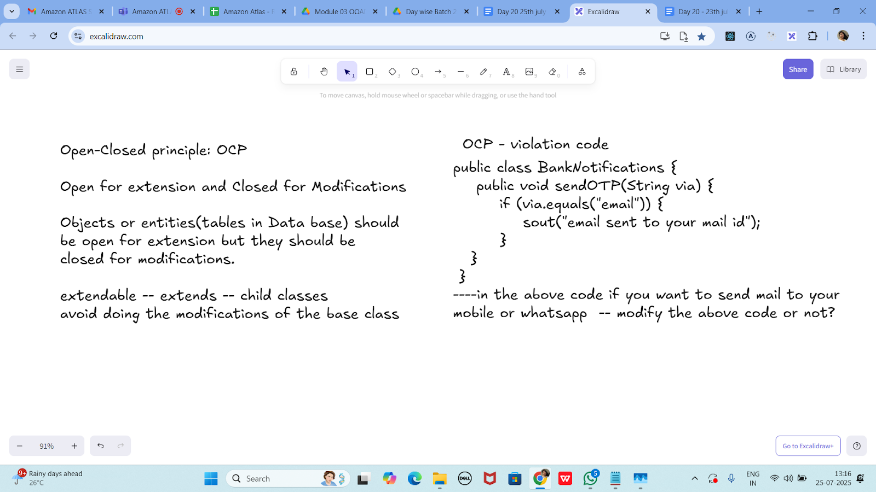

public class BankNotifications {
public void sendOTP(String via) {
if (via.equals("email")) {
sout("email sent to your mail id");
}
}
}
----in the above code if you want to send mail to your
mobile or whatsapp -- modify the above code or not?

public class BankNotifications {
public void sendOTP(String via) {
if (via.equals("email")) {
System.out.println("Email sent to your mail ID");
} else if (via.equals("sms")) {
System.out.println("OTP sent via SMS");
} else if (via.equals("whatsapp")) {
System.out.println("OTP sent via WhatsApp");
}
}

public static void main(String[] args) {
BankNotifications notify = new BankNotifications();
notify.sendOTP("email");
notify.sendOTP("sms");
notify.sendOTP("whatsapp");
}
}

OCP - implementation

public interface BankNotifications {
public void sendOTP(String via);
//public void TransactionNotification(Srting via);
//violates srp so .. include another interface
}

class EmailNotify implements BankNotifications {
public void sendOTP(String via) {
sout("email sent to your mail id");
}
/*public void TransactionNotification(String via) {
sout("email sent to your mail id");
}*/
}
class MobileNotify implements BankNotifications {
public void sendOTP(String via) {
sout("msg sent to your Mobile no");
}
/*public void TransactionNotification(String via) {
sout("msg sent to your Mobile no");
}*/
}
class WhatsappNotify implements BankNotifications {
public void sendOTP(String via) {
sout("msg sent to your whatsapp ");
}
/*public void TransactionNotification(String via) {
sout("msg sent to your whatsapp");
}*/
}

// sending a physical notification.. extend here..

// Interface for OTP notifications
interface BankNotifications2 {
void sendOTP();
}

// Email notification implementation
class EmailNotify implements BankNotifications2 {
public void sendOTP() {
System.out.println("OTP sent to your email.");
}
}

// SMS notification implementation
class MobileNotify implements BankNotifications2 {
public void sendOTP() {
System.out.println("OTP sent to your mobile.");
}
}

// WhatsApp notification implementation
class WhatsappNotify implements BankNotifications2 {
public void sendOTP() {
System.out.println("OTP sent to your WhatsApp.");
}
}

// Physical letter notification (extending system without modifying existing classes)
class PhysicalNotify implements BankNotifications2 {
public void sendOTP() {
System.out.println("OTP sent via physical mail.");
}
}

// Main class to use any notification
public class OCP_Example {
public static void main(String[] args) {
BankNotifications2 notify1 = new EmailNotify();
BankNotifications2 notify2 = new MobileNotify();
BankNotifications2 notify3 = new WhatsappNotify();
BankNotifications2 notify4 = new PhysicalNotify();

notify1.sendOTP();
notify2.sendOTP();
notify3.sendOTP();
notify4.sendOTP();
}
}

Task 3:
The below is violating SRP complete it and also … plz implement the SRP principle and rewrite the code.
// srp violation

public class Book {
private String title;
private String author;
private double price;

public Book(String title, String author, double price) {
this.title = title;
this.author = author;
this.price = price;
}

public String getFormattedTitle() {
return "Title: " + title.toUpperCase();
}

public double calculateDiscountedPrice(double discountPercentage) {
return price * (1 - discountPercentage);
}

// ... other methods for book details
}
public class Book {
private String title;
private String author;
private double price;

public Book(String title, String author, double price) {
this.title = title;
this.author = author;
this.price = price;
}

// Presentation logic mixed in — violates SRP
public String getFormattedTitle() {
return "Title: " + title.toUpperCase();
}

// Business logic mixed in — violates SRP
public double calculateDiscountedPrice(double discountPercentage) {
return price * (1 - discountPercentage);
}

public static void main(String[] args) {
Book book = new Book("Clean Code", "Robert C. Martin", 500.0);

System.out.println(book.getFormattedTitle());
double discountedPrice = book.calculateDiscountedPrice(0.10); // 10% discount
System.out.println("Discounted Price: ₹" + discountedPrice);
}
}

Task 04:

class Employee {
private String name;
private String email;
private double salary;

// Methods related to employee data

// Method to generate PDF report
public void generatePdfReport() {
// Code to generate PDF report
}

// Method to send email
public void sendEmail() {
// Code to send email
}
}
In the above example code, the Employee class violates the SRP because it has multiple responsibilities: managing employee data, generating PDF reports, and sending emails. These responsibilities are not cohesive and may change for different reasons.
public class Employee {
private String name;
private String email;
private double salary;

public Employee(String name, String email, double salary) {
this.name = name;
this.email = email;
this.salary = salary;
}

// Core responsibility: Employee data
public String getDetails() {
return "Name: " + name + ", Email: " + email + ", Salary: ₹" + salary;
}

// Additional responsibility: Report generation — violates SRP
public void generatePdfReport() {
System.out.println("Generating PDF report for " + name);
// Imagine actual PDF code here
}

// Additional responsibility: Sending email — violates SRP
public void sendEmail() {
System.out.println("Sending email to " + email);
// Imagine actual email code here
}

public static void main(String[] args) {
Employee emp = new Employee("Alice", "alice@example.com", 60000);
System.out.println(emp.getDetails());
emp.generatePdfReport(); // Not Employee's responsibility
emp.sendEmail(); // Not Employee's responsibility
}
}

2.55 to 3pm

Implementing SRP:

class Employee {
private String name;
private String email;
private double salary;

// Methods related to employee data
}

class ReportGenerator {
public void generatePdfReport(Employee employee) {
// Code to generate PDF report using employee data
}
}

class EmailSender {
public void sendEmail(String recipient, String message) {
// Code to send email
}
}

class Employee2 {
private String name;
private String email;
private double salary;

public Employee2(String name, String email, double salary) {
this.name = name;
this.email = email;
this.salary = salary;
}

public String getName() {
return name;
}

public String getEmail() {
return email;
}

public double getSalary() {
return salary;
}

public String getDetails() {
return "Name: " + name + ", Email: " + email + ", Salary: ₹" + salary;
}
}

// Single Responsibility: Generating reports
class ReportGenerator {
public void generatePdfReport(Employee2 Employee2) {
System.out.println("Generating PDF report for " + Employee2.getName());
// Simulated report generation
}
}

// Single Responsibility: Sending emails
class EmailSender {
public void sendEmail(String recipient, String message) {
System.out.println("Sending email to " + recipient);
System.out.println("Message: " + message);
// Simulated email send
}
}

// Main class for testing
public class SRPExample {
public static void main(String[] args) {
Employee2 emp = new Employee2("John Doe", "john@example.com", 75000);

ReportGenerator reportGen = new ReportGenerator();
EmailSender emailSender = new EmailSender();

System.out.println(emp.getDetails());

reportGen.generatePdfReport(emp);
emailSender.sendEmail(emp.getEmail(), "Your PDF report is ready.");
}
}

Task 05:

Open closed Principle …

class Square() {
int height;
int area() { return height * height; }
}

public class OpenOpenExample {

public int compareArea(Square a, Square b) {
return a.area() - b.area();
}

}
extension code:

class Circle {
int r;
int area() { return Math.PI*r*r*;}
}

class OpenOpenExample {

public int compareArea(Square a, Square b) {
return a.area() - b.area();
}

public int compareArea(Circle x, Circle y) {
return x.area() - y.area();
}

}

3.00 to 3.05

class Square {
int height;

Square(int height) {
this.height = height;
}

public int area() {
return height * height;
}
}

class Circle {
int r;

Circle(int r) {
this.r = r;
}

public int area() {
return (int)(Math.PI * r * r); // casting to int for simplicity
}
}

public class OpenOpenExample {

// Not scalable — violates OCP
public int compareArea(Square a, Square b) {
return a.area() - b.area();
}

public int compareArea(Circle x, Circle y) {
return x.area() - y.area();
}

public static void main(String[] args) {
Square s1 = new Square(4);
Square s2 = new Square(6);

Circle c1 = new Circle(3);
Circle c2 = new Circle(5);

OpenOpenExample example = new OpenOpenExample();

System.out.println("Square area difference: " + example.compareArea(s1, s2));
System.out.println("Circle area difference: " + example.compareArea(c1, c2));
}
}

--------------------------------------------------------------------

Applying the open-closed principle in Java

interface Shape {
int area();
}

class Circle implements Shape {
int r;
int area() { return Math.PI*r*r*;}
}

class Square() implements {
int height;
int area() { return height * height; }
}

public class OpenClosedExample {

public int compareArea(Shape a, Shape b) {
return a.area() - b.area();
}

}

interface Shape {
int area();
}

class Circle2 implements Shape {
int r;

Circle2(int r) {
this.r = r;
}

public int area() {
return (int)(Math.PI * r * r); // Cast to int for simplicity
}
}

class Square2 implements Shape {
int height;

Square2(int height) {
this.height = height;
}

public int area() {
return height * height;
}
}

public class OpenClosedExample {

public int compareArea(Shape a, Shape b) {
return a.area() - b.area();
}

public static void main(String[] args) {
Shape s1 = new Square2(5);
Shape s2 = new Circle2(3);

OpenClosedExample example = new OpenClosedExample();
System.out.println("Area difference: " + example.compareArea(s1, s2));
}
}

UML:

UML - Unified modeling Language

plantUML:
extension in vscode..

Drawio...

uml is used for defining a standard way
to visualize the way the system
needs to be designed.

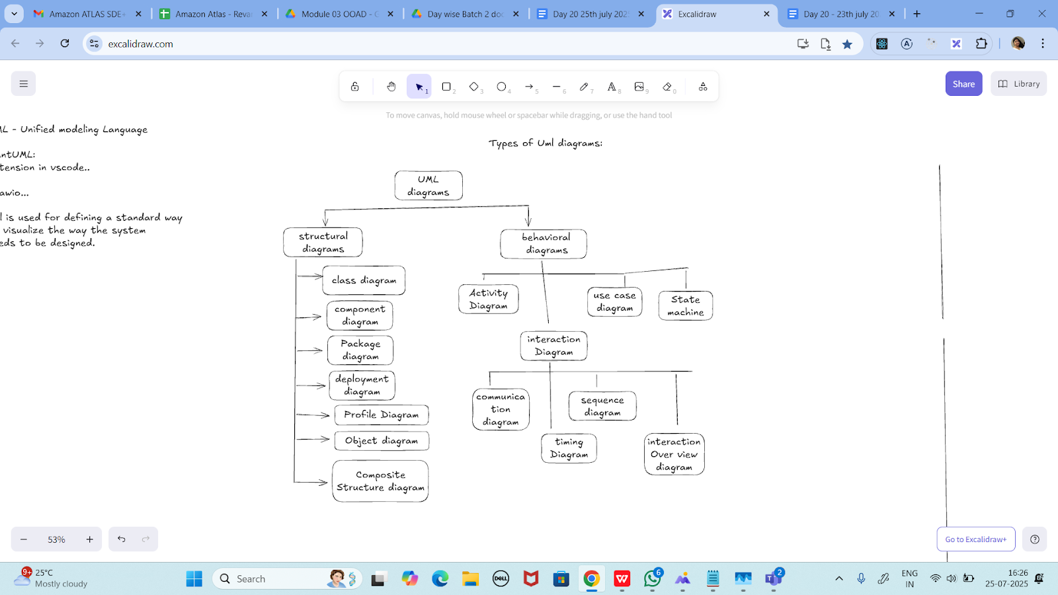

Task 06:

Can you guys create diagrams for structural diagrams…

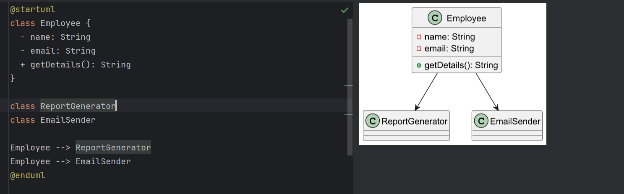

==============================================================

Info box:

=============================================================

https://excalidraw.com/#json=koAtUznEAcXbBLQqRRH1K,SDnPak_Xh1EPkRD7vKH--A

The above link updated// plz click below link

https://excalidraw.com/#json=KJCtzEJJ4apOcoW0CEq-e,PrVjs6qYCOMlOnp_oVqgfg

==============================================================

=============================================================

